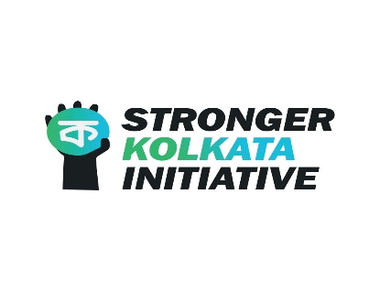
The Stronger Kolkata Initiative was started by Mr. Ankit Pal, student of NUJS, Kolkata, and Mr. Sayan Bhattacharya, student of NALSAR, Hyderabad. The initiative is a student collective which started off with the objective of reaching out to individuals, families and communities affected by the Covid 19 pandemic and the Super-cyclone Amphan, Bengal`s dual crisis.
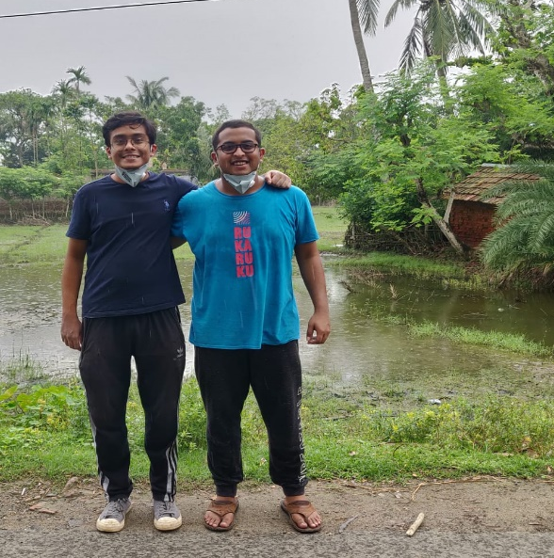
The initiative started with a targeted attempt to deliver relief to a small slum community in Beleghata which consisted of 14 families. This community was adopted by Prof. (Dr.) Shamnad Basheer during his time at NUJS, Kolkata. Both, Ankit and Sayan have been Deputy Team Leaders of IDIA at their respective law schools.
The student collective consists of an active volunteer network that has thus far sought to respond to two majorly disruptive occurrences: i) Destruction caused by Cyclone Amphan; ii) COVID-19 Lockdown-related loss of livelihood and/or employment.
The Stronger Kolkata Initiative has reached out to 755 families in and around Kolkata with essential rations, sanitary napkins, clothing and drinking water. In this process, we have reached out to slum dwellers, maids, daily wage earners, rickshaw-pullers, etc. We decided to extend our operations beyond Kolkata, in recognition of the even greater quantum of damage and loss suffered in the rural hinterland of West Bengal. With this in mind, we set up Stronger Bhangor, Stronger Sunderbans and Stronger North 24 parganas campaigns. Thus far, we have reached out to 175 families in Bhangor, 1760 families in Sunderbans, as well as 380 families in North 24 Parganas. Our deliveries consisted of essential rations, tarpaulin sheets, sanitation items and medicinal supplies.
We have reached out to affected people in Kolkata, in Bhangor and Sonarpur which are located in the suburbs of Kolkata as well as in Shritopinagar and Hashnabad which are very close to the Bangladesh border. Our targeted relief effort in Shritopinagar was funded by NALSAR for Migrant Workers. We reached out to 900 families in the Shritopinagar island with the help of an IDIA Scholar, Mr. Jiyarul Hoque who is currently studying in NLU, Orissa and is a resident of the same island. A number of lawyers like Senior Advocate Mr. Shyam Divan, Additional Solicitor General of India, Mrs. Madhavai Divan and Ms. Nandini Khaitan have supported our initiative. We thank all the people who have donated to us and helped us reach out to the affected communities.
We conducted a Mask Distribution and Awareness drive in Kolkata wherein we distributed masks to 10,000 people at 20 different busy locations of the city in a single day. We have distributed 1300 packets of sanitary napkins and we shall be conducting a mass distribution and menstrual health awareness campaign in the near future.
We have several projects planned for the near future. These include an initiative facilitating the re-opening of primary educational facilities in villages across the state, an extensive tree-plantation drive in Gosaba, and desalinisation projects to facilitate the restoration of fertility and productivity to agricultural land damaged by floods. We also intend to expand our operations in the direction of community engagement and employment regeneration through contact and constructive collaboration with local authorities.
We intend to move towards making structural interventions in the future in order to help these affected communities and achieve long term solutions. However, the status quo is filled with lack of access to basic ration and sanitation facilities in most of these places in the aftermath of Amphan. Bhangor, Sonarpur, Piyali Islands, Shritopinagar Islands, Baduria, Baunia, Hashnabad, etc, are some of the names of places where we have reached out to affected communities. They all share a common problem, hunger, destruction and devastation in the middle of Bengal`s dual crisis.
The Stronger Kolkata Initiative is empowered by the spirit of IDIA and the teachings of its founder. We have reached out to more than 12,000 people till date and we hope to reach out many more people who have been badly hit in the current crisis. Help us help others for a stronger tomorrow.

You can follow our work on our social media handles;
Facebook: Stronger Kolkata Initiative
Instagram: @strongerkolkatainitiative
You can contact us at 9831122932 (Ankit) and 9163187560 (Sayan).

