20.07.2020

THE HON’BLE CHIEF JUSTICE OF INDIA AND OTHER COMPANIAN JUDGES
OF THE HON’BLE SUPREME COURT OF INDIA

Respected Lordships,

I write this letter to bring your kind attention towards the rising concerns of the safety of millions of final year students and their families, invigilators, evaluators, transport authorities, support staff and several other key stakeholders, either directly or indirectly, involved in the examination process.

The Covid-19 cases in India are rising exponentially and as on date, the official figures indicate over 11,10,000 cases with Maharashtra accounting for the maximum - over 3,10,000 cases. As per the data made available by All India Institute of Medical Sciences (AIIMS), India could witness a peak in COVID-19 cases as late as in mid-November. Taking the extremely serious situation into consideration, the Chief Minister of Maharashtra wrote to the Hon’ble Prime Minister on 25.6.20 (ANNEXURE 1), bringing to the Prime Minister’s attention the extremely delicate situation in the State of Maharashtra. It was pointed-out that it would not be feasible to hold the final year/final semester examinations for professional courses in view of the deteriorating situation in various parts of Maharashtra, including Pune. The letter pointed-out that the State had decided not to go ahead with the final exams as afore-mentioned. In line with the same, an appeal was made to the Hon’ble Prime Minister to instruct the concerned apex authorities (like All India Council for Technical Education, Bar Council of India, National Council of Teachers Education etc) to issue guidelines to the Universities in this regard. However, the Ministry of Home Affairs thereafter granted permission for conducting the examinations by universities and institutions (ANNEXURE 2).
Accordingly, the Universities Grants Commission (“UGC”) issued revised guidelines for final year examinations vide notification dated 06.07.2020 (ANNEXURE 3).

UGC has provided universities the option to conduct exams in either an offline (pen and paper) or online or blended (offline + online) mode. Online mode of examinations, however, neglects socio-economic diversity and inequality of internet access. Likewise, holding physical examinations has its own glaring set of shortcomings. Whether the offline or online or blended mode is adopted, there are a myriad number of practical, technological and institutional difficulties that are sure to be encountered.

To highlight the grim situation, it would be necessary to state that a large section of students reside either indifferent parts of India or in other countries. Mandating terminal semester examinations would compel these students to travel inter-state amid the virus, share rooms with other students, make arrangements for food and undergo quarantine before appearing for examinations. More worryingly, students and all others connected with the conduct of such exams could be potential carriers of the virus thereby posing a serious health hazard to all those that they come in contact with in the process of reaching exam centres.

If compulsorily required to appear for the examinations, students would undoubtedly be exposed to risks of the Covid-19 pandemic. Several exam centres, colleges and hostels have already been converted into quarantine facilities and Covid care centres. The UGC has issued an SOP for the Conduct of Examinations. (ANNEXURE4). Nevertheless, its implementation is deeply mired in challenges. Ensuring cleanliness and safety standards as stipulated in the SOP in each and every exam centre, spread out in all nooks and corners of the country, including centres located in rural areas is near impossible. Besides being a huge health hazard for thousands and thousands associated with the whole examination process, it is an unnecessary burden on the infrastructure that is already gasping for breath. The State government has clearly expressed its apprehensions and unwillingness to bear this additional burden.

Soon after the UGC Guidelines were released, the Maharashtra Government unequivocally reiterated its inability to hold final year examinations in a letter addressed to the Ministry of Human Resource Development (ANNEXURE 5). It is pertinent to note here that even premier institutions like IITs have waived all examinations. CBSE, ICSE, IGCSE and many State Boards have also cancelled examinations. Moreover, UGC itself has cancelled all intermediate examinations. UGC’s guidelines, which mandatorily require final year students to appear for examinations by September end, is arbitrary and in blatant disregard of the fundamental rights guaranteed by our Constitution. These guidelines exempt students enrolled in intermediate semesters from appearing for examinations and instead provide for their promotion based on previous years’ performance. Insisting on the conduct of examinations for final year students is discriminatory. It is highly regretful that an arbitrary distinction is being drawn between intermediate and final year students. If this exercise were to be carried out, the lives of all final year students pan India would be put in grave peril. This is evinced by the recent Karnataka SSLC exam fiasco where 32 students tested positive. There certainly cannot be a distinction made amongst various sets of students when the whole world is in the grip of a deadly pandemic. The risk of catching the virus and that of it spreading in large numbers by exposing thousands in a thoroughly avoidable exercise certainly makes no exception between final year students and the rest.

The earlier guidelines released by UGC in the month of April required final year examinations to be held by July end. After having taken stock of the bleak situation, the revised guidelines have now extended the time period for the conduct of examinations to September end. However, there is no certainty that the situation would improve within this short span. On the contrary, many experts believe that India is about to see a surge, a finding backed by the latest numbers where we have now reached a stage where we have had 40,000 cases a day. If the time period for the conduct of examinations were to be extended once again, graduating students are at risk of losing nearly an entire academic year. Being insistent on the conduct of examinations could further effectively translate into revoked job offers, deferred post graduate admissions, mass unemployment and sheer chaos for a sizeable percentage of students.

It is apparent that the prevailing atmosphere is not conducive for holding physical examinations. The unabated focus on mandating university exams and sticking to traditional patterns is indicative of the flaws in our higher education system. Our strict examination-oriented culture has frequently come under fire for failing to develop practical skills and critical reasoning. Credibility and intellectual prowess has little to or has no connection with examination grades. The crisis has the potential for reforming our education system. In times like these, holding examinations is not the answer but would serve the sole purpose of endangering the wellbeing of distressed students and other machinery ancillary to the examination process.

Conducting pan-India examinations in the midst of the novel pandemic would be equivalent to turning a blind eye to the interests and genuine concerns of the student fraternity, besides putting the country at a far greater risk by making this a potential reason for a possible community spread. The conduct of examinations in these extenuating circumstances would pose a grave concern for the health and safety of millions of individuals who are parties to the examination process. I humbly request you to take suo-moto cognizance of this letter and to kindly resolve the issue.

Yours faithfully

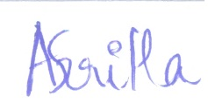
Anshritha Rai
Final Year student,
ILS Law College, Pune

ANNEXURE 1

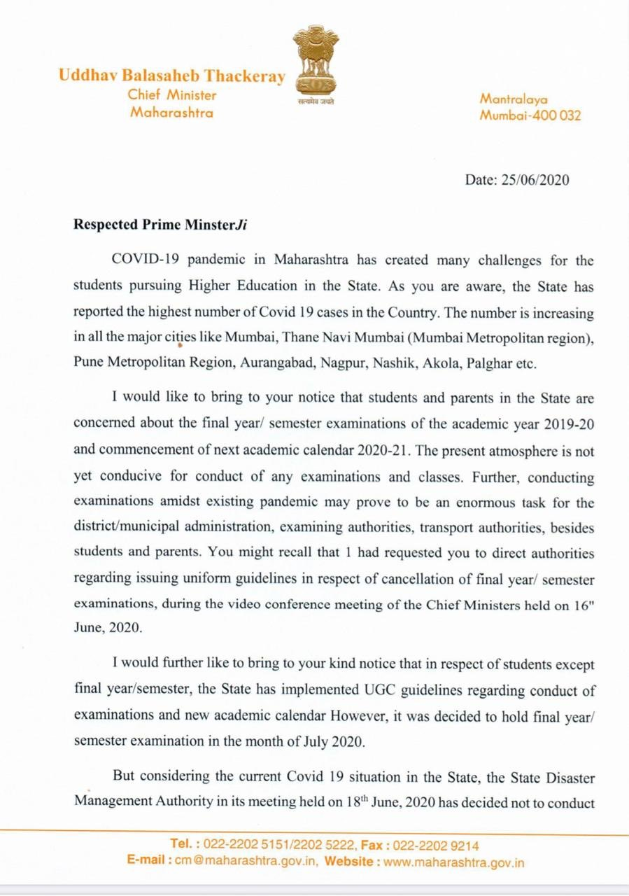

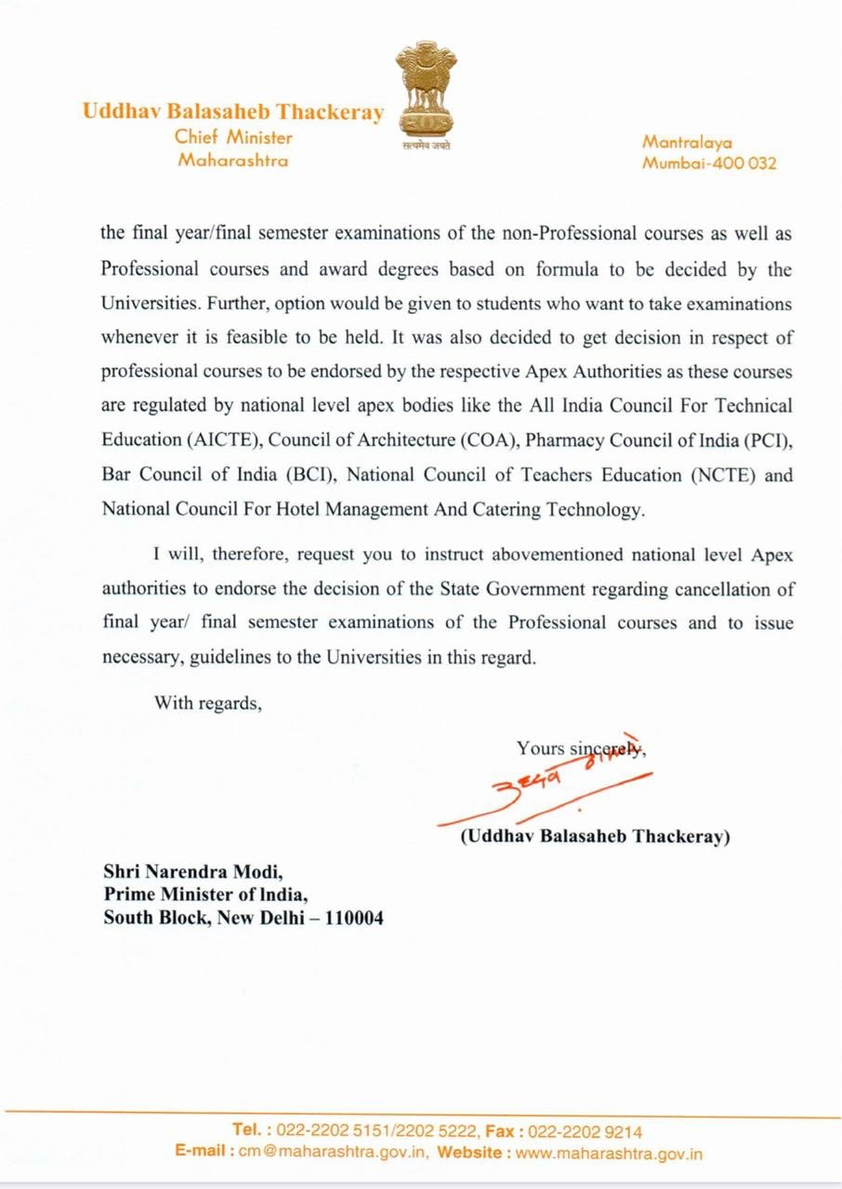

ANNEXURE 2

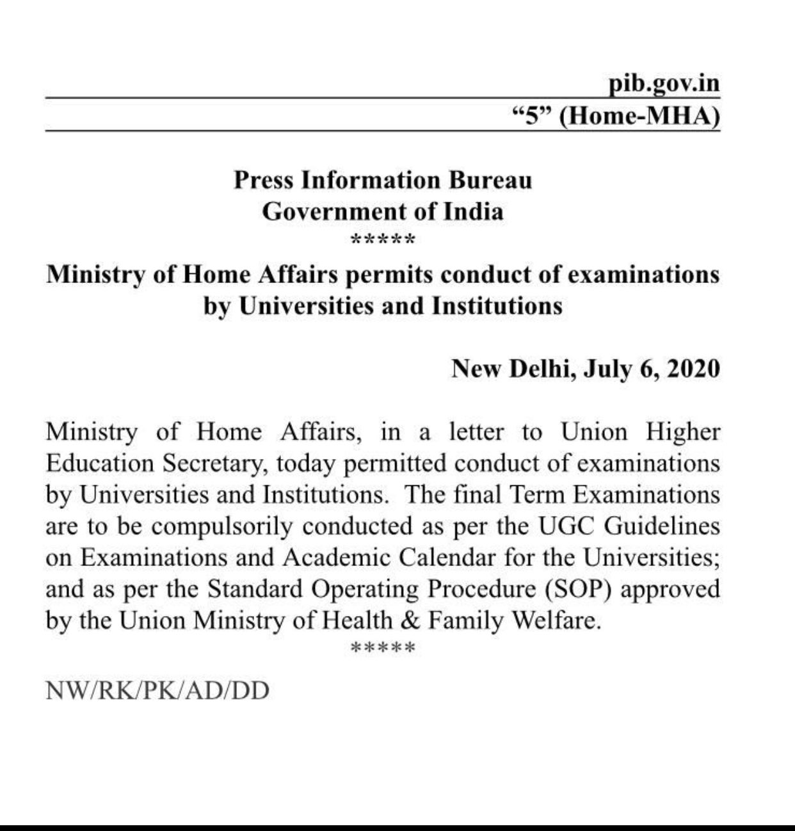

ANNEXURE 3

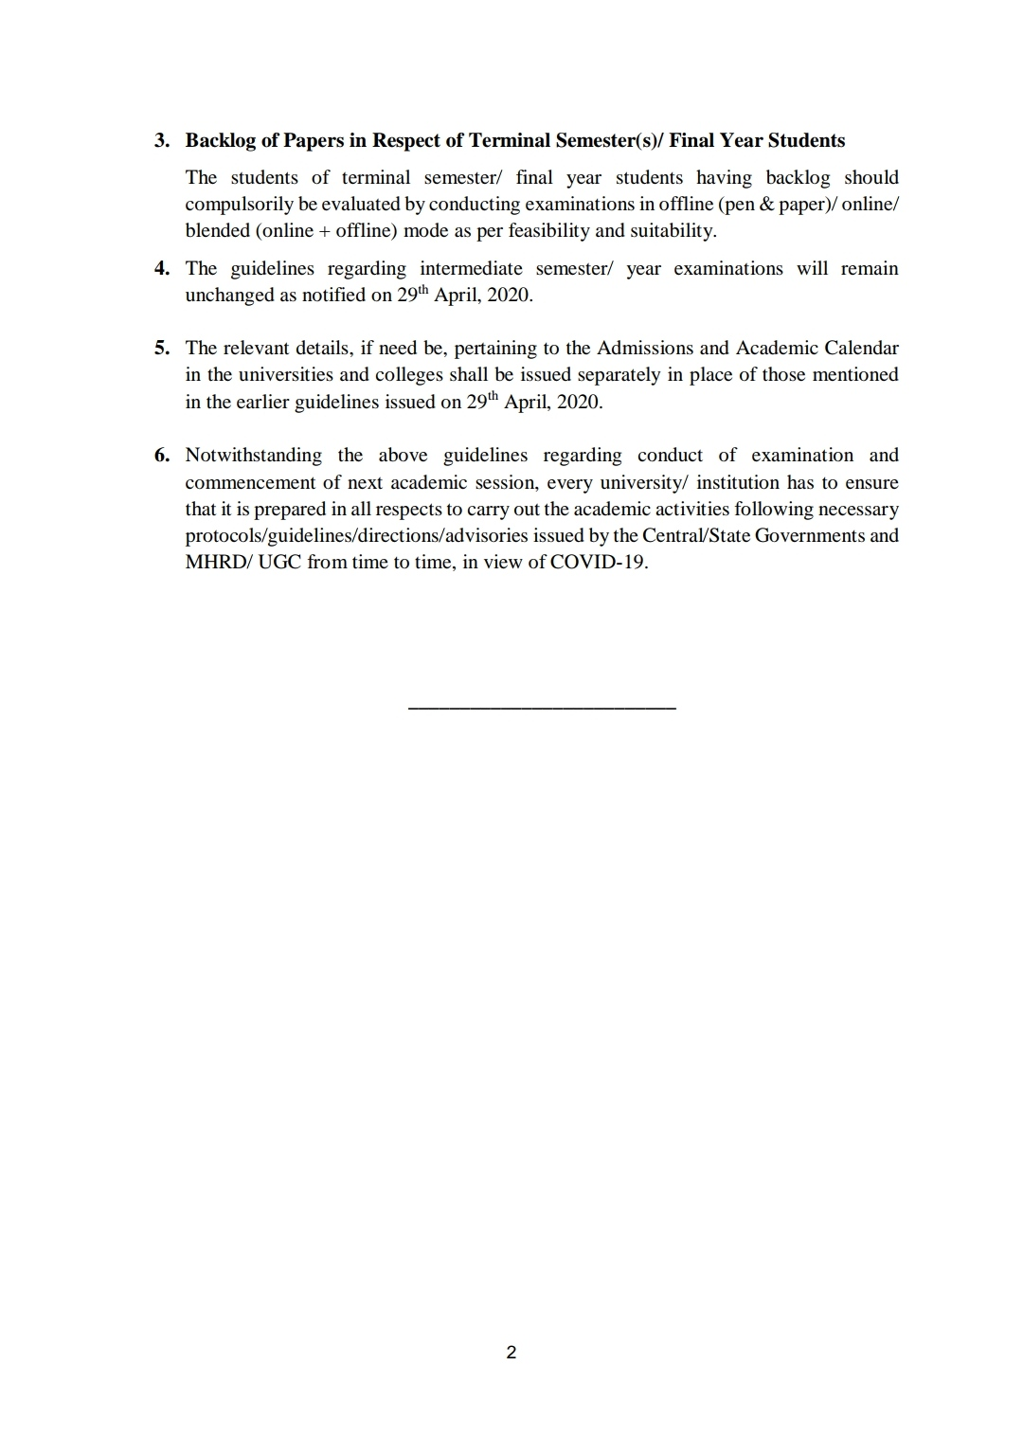

ANNEXURE 4

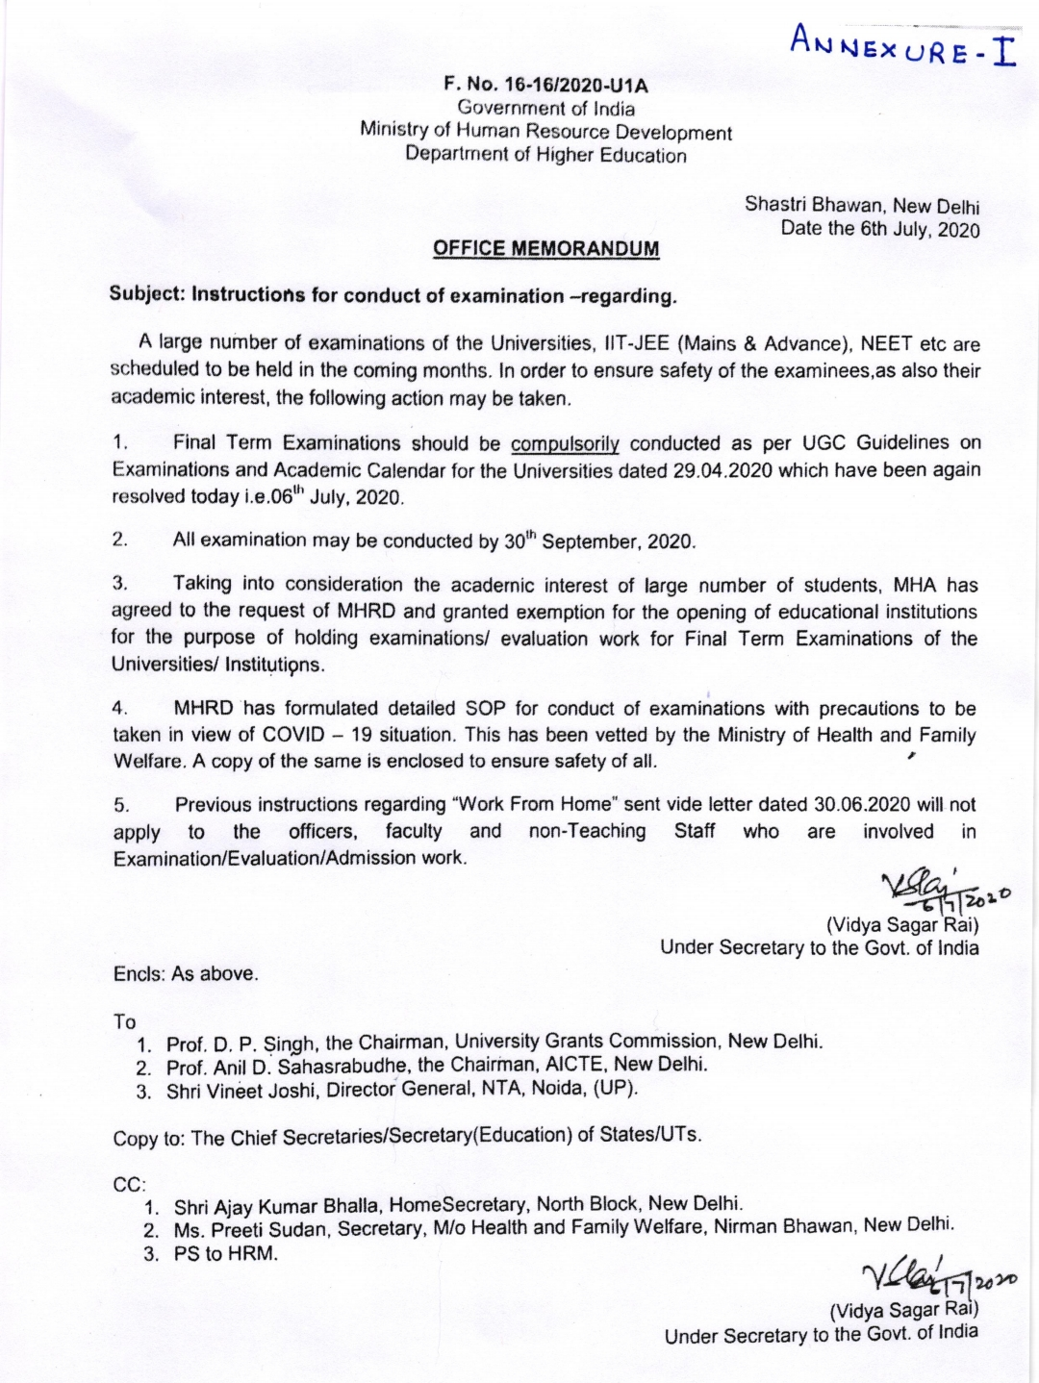

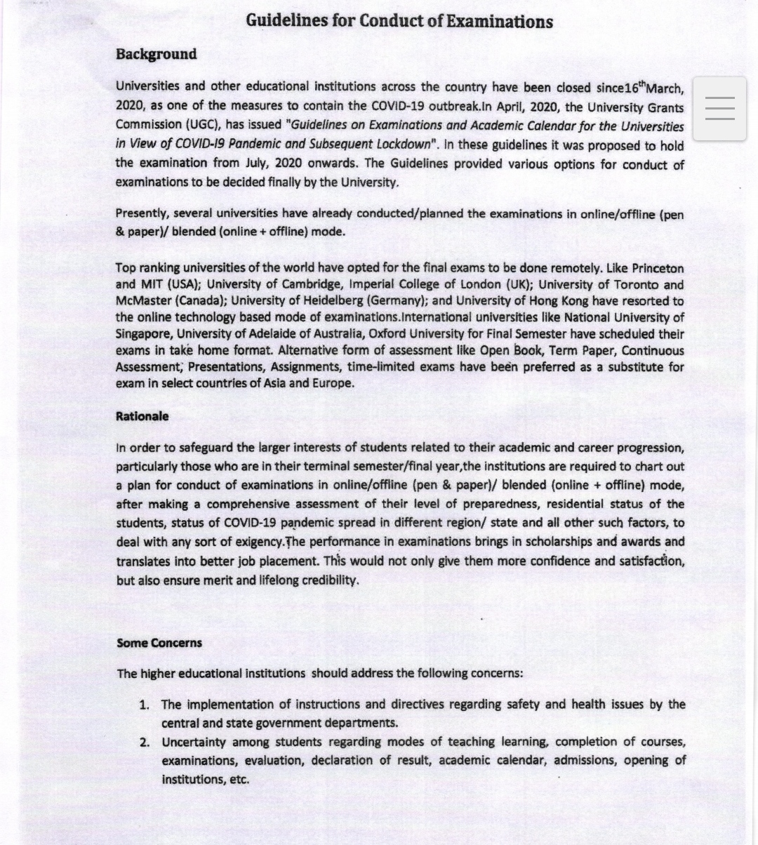

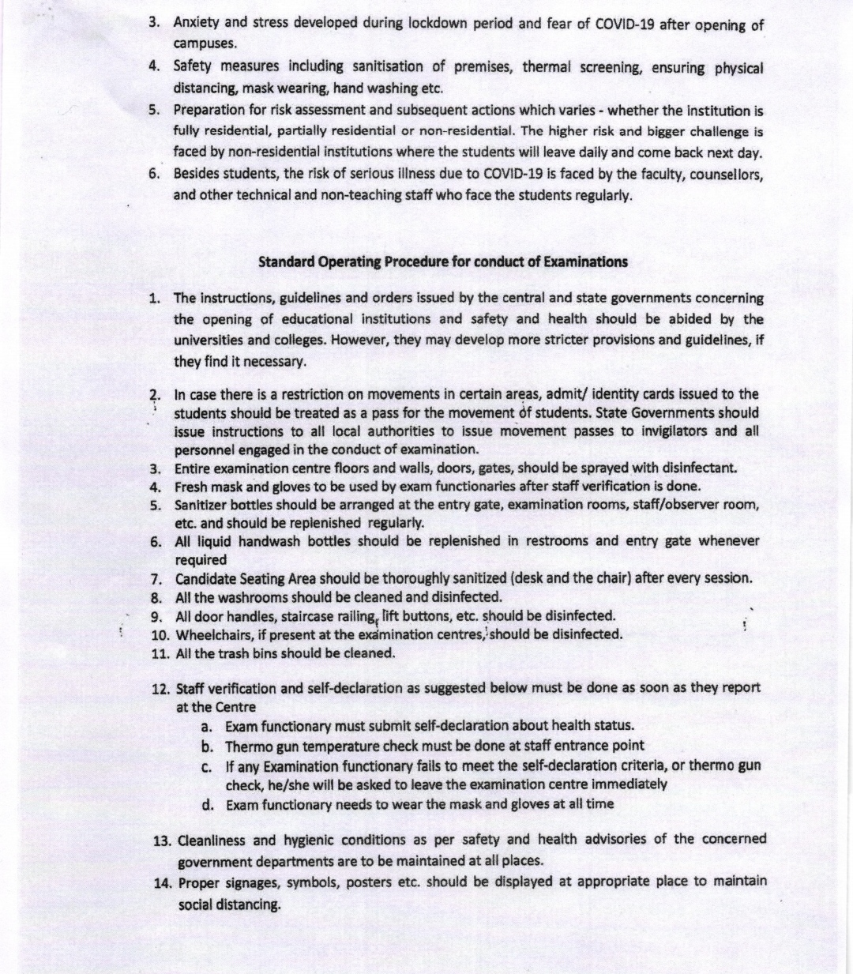

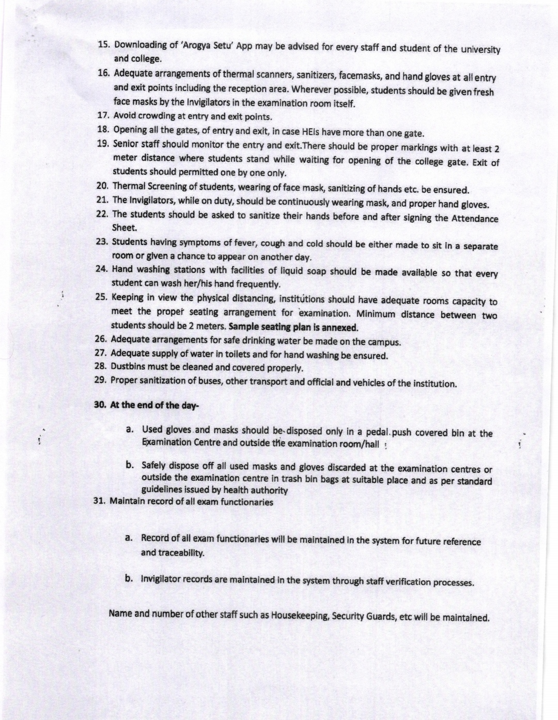

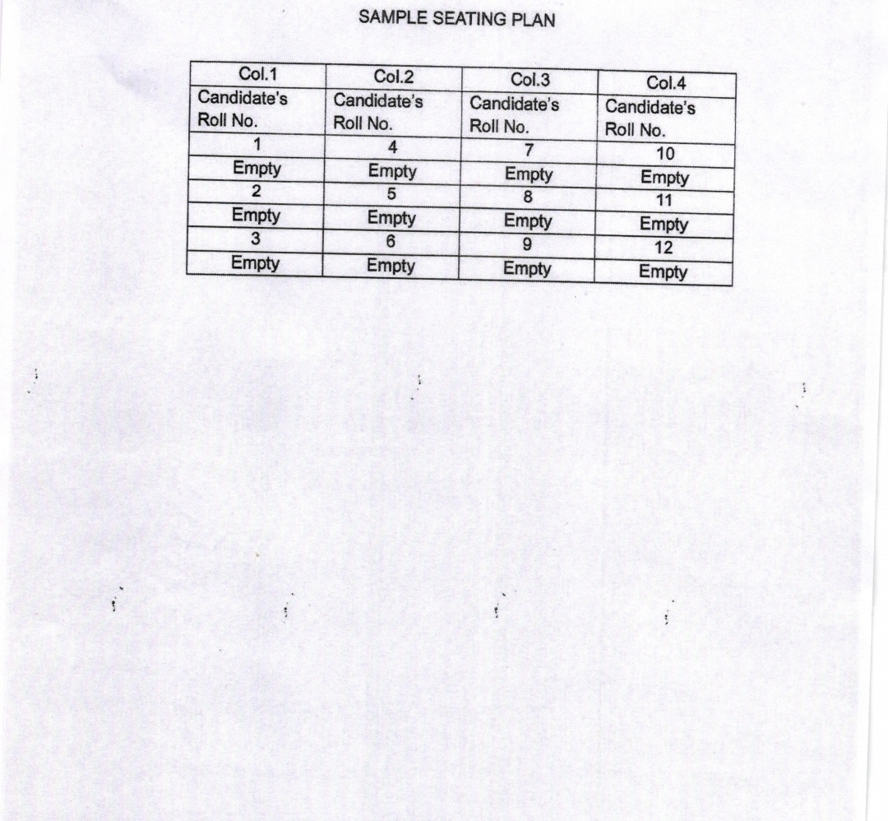

ANNEXURE 5

