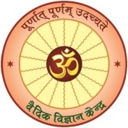
CENTRE FOR VEDIC SCIENCE
Banaras Hindu University
Varanasi-221005

NATIONAL WORKSHOP
ON
Vedic Jurisprudence & its impact on
Contemporary World
(वैदिक विधिशास्त्र एवं समसामयिक विश्व पर उसका प्रभाव)
Registration Form

Date: 22 - 23 February, 2020 (Saturday & Sunday)
Programme Timing: 10:00 AM - 5:00 PM
Venue: Seminar Hall Complex, Malaviya Mulya Anushilan Kendra,
Banaras Hindu University, Varanasi-221005

Name (Capital Letter) :...............................................................................................................
Designation: ................................................................................................................................
Address: ......................................................................................................................................
Email:………………………………………..............................................................................
Mobile No.: ................................................................................................................................
Registration Fee: ........................................................................................................................
* No accommodation will be provided to the participants.

Signature

