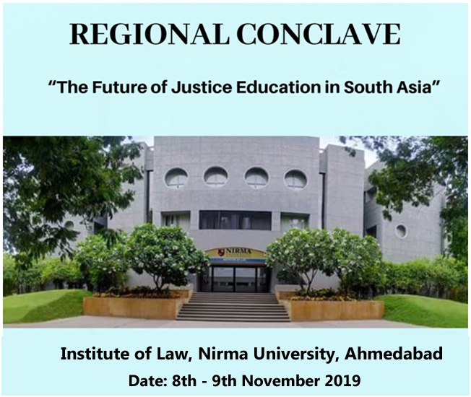

ORGANIZED BY-

INSTITUTE OF LAW,
NIRMA UNIVERSITY,
SARKHEJ GANDHINAGAR HIGHWAY, AHMEDABAD, GUJARAT, INDIA, 382481

OVERVIEW OF THE CONCLAVE

The Regional Conclave on The Future of Justice Education in South Asia is the inaugural edition of what we hope will become a regular annual or biennial gathering of leading South Asian educators and practitioners focused on Justice Education. The two-day conclave will take place at the Institute of Law, Nirma University in Ahmedabad, Gujarat on 8th & 9th November, 2019. The conclave seeks to bring together clinical practitioners and educators from across the SouthAsian region on a common platform through a series of panel discussions, interactive sessions, and informal networking conversations addressing new approaches and initiatives, best practices, collaborative opportunities and insights on recurrent challenges in the theory and practice of justice education. The organizers will be able to waive registration costs for all selected applicants who demonstrate a genuine requirement of a registration fee waiver. Accommodation and partial travel expenses for a limited number of successful applicants will be possible depending on the availability of funding.

Main Goals

- To develop and commit to publishing a body of relevant and useful knowledge relating to justice education in India and South Asia.
- To enable justice educators and practitioners to take stock of what has been done in justice education in India and South-Asia
- To share and foster dialogue on new approaches and initiatives, best practices, collaborative opportunities, and insights on addressing recurrent challenges in the context of justice education in SouthAsia;
- To build commitment and momentum for a new collaborative network of justice educators and practitioners in the South Asian region.

Participants at the Regional Conclave will present their work at four panel discussions spread across two days. Panel presenters will be required to submit a short essay draft (3000 - 5000 words) to the organisers by the stipulated date in October 2019. Drafts will be circulated to all conclave participants, and panelists will also be encouraged to contribute final revised essays for a proposed edited volume on justice education in South Asia to be published in 2020.

BROAD PANEL THEMES

Theme 1: New Approaches and Initiatives in Clinical Legal Education
We are particularly interested in new initiatives from South Asia that creatively adopt the clinical legal education approach to promote learning and advance social justice.

Theme 2: Working with Communities
We are particularly interested in the foundational vision, organisational modalities, and impacts of clinical legal education initiatives that are strongly focused on working with underserved communities in South Asia. Theoretical work and practical insights on engaging with vulnerable and marginalised communities are also welcome!

Theme 3: Learning Outcomes and Justice Education
We are particularly interested in theoretical work and initiatives that reconcile learning outcomes from justice education with commitments towards social justice outcomes in specific parts of South Asia. Theoretical work and practice-based insights on designing and assessing learning outcomes for justice education in South Asia are also welcome!

Theme 4: Collaboration in Justice Education
We are particularly interested in theoretical work and practice-based insights that explore best practices for collaboration in justice education in specific parts of South Asia.

Please note that the broad themes are not exhaustive, and we welcome interesting submissions on any issue pertaining to justice education in South Asia.
Specially-invited respondents and conclave participants will provide feedback, raise questions, and contribute to a constructive dialogue based on the presentations made at the panel sessions. A longer-duration interactive special session on day 2 of the conclave will focus on a strategy road-map to create a new network for justice educators and practitioners in India and the larger South Asian region.
All participants will be conferred with Certificates of Participation and included in the proposed new network for justice education in South Asia.

BACKGROUND & VISION

The regional conclave has been conceptualized by four justice educators from India, Mr. Abhayraj Naik, Ms. Asha Bajpai, Ms. Purvi Pokhariyal, and Ms. Sarasu Esther Thomas, who collectively have a wealth of experience in clinical legal education, access to justice initiatives, human rights lawyering and research, community empowerment, social impact and development, and justice education. The conclave responds to the lack of an adequate collaborative platform and the paucity of high-quality research at the Indian and the South Asian regional levels for educators and practitioners involved in justice education and the promotion of human rights. The conclave seeks to build a new collaborative network for justice education and human rights promotion in the South Asian region, and an empowered pioneering community of justice educators and practitioners with a common vision and motivation to collaboratively promote justice education and human rights.

Application Guidelines:
- Applications to participate in the regional conclave need to be sent by email to rgajeconference@nirmauni.ac.in by the stipulated date. Applications should include a covering letter, a short statement relating to the need for a registration fee waiver/accommodation grant/ travel grant (if applicable), and an essay draft as an attachment. Incomplete applications will not be considered.
- Applicants must be willing and able to participate for the entire duration of the 2-day conclave.
- Joint applications and essay authorship are permitted upto a maximum of two collaborators. At least one applicant must attend the conclave to present the work and participate in the sessions.
- The cover letter sent as part of the application should mention the Name of the Author(s), Professional Position/ Course/Year of Study (as applicable), Name of the Institution/College/University, Postal Address, Email Address and Contact Number.
- The Essay draft must not exceed a maximum of 5000 words (excluding footnotes/endnotes/annexure/reports etc.) and should be submitted as an email attachment in PDF and MS Word formats along with the application.
- The statement relating to the need for a registration fee waiver/accommodation grant/travel grant should indicate the specific circumstances of the applicant’s need for funding support, any past work done in the area of justice education, and possible alternate sources of funding support for participation in the conclave.

CONFERENCE ORGANIZERS

PROF. ABHAYRAJ NAIK

Abhayraj Naik is an advisor, consultant and researcher based in Bengaluru, India. He is currently a Visiting Faculty at Azim Premji University. He is a member of the Board of Studies for Urban Studies at the Bengaluru Central University and was earlier affiliated with the Environment Support Group, Bangalore for over a decade. He has taught at the National Law School of India University, Azim Premji University, OP Jindal Global University, and the Minnesota Studies in International Development: India Program. As the inaugural coordinator of the Hub for Law and Policy at Azim Premji University, in 2017, he led the planning and organisation of a first-of- its-kind international conference in India called ‘Crafting Justice’ (https:// craftingjustice.wordpress.com), which focused on pedagogies and practices of interdisciplinary and multidisciplinary justice education. His ongoing independent research focuses on justice education, environmental law and policy, urban studies, technology policy, and transformation theory. Abhayraj is a graduate of the National Law School of India University and Yale Law School. He attended the GAJE conference in Mexico in December 2017 where he presented as part of two panel discussions on “Crafting Justice through Clinical Legal Education” and “Teaching legal ethics to break down walls: how teaching legal ethics can empower students and lawyers to strengthen and improve the legal systems in which we work”.

PROF. (DR.) ASHA BAJPAI

Dr. Asha Bajpai is a Professor of Law and Founder Dean of the School of Law at the Tata Institute of Social Sciences (TISS), Mumbai. She has been involved in teaching, research, training and legislative reform for more than three decades. Her specializations are child rights laws and social legislations relating to the marginalized and vulnerable. She has designed and organized access to justice and legal services clinics in marginalized communities. She has prepared several street law materials for communities in English as well as local languages. She has also designed a unique Masters in Law curriculum titled ‘Access to Justice’, to prepare community lawyers to provide social justice to the community. She has been a GAJE member right from its inception. She was a member of the first Steering Committee of GAJE and has attended and made several presentations at GAJE Conferences in Thiruvanthapuram, Eskisheir (Turkey) and Valencia. She is currently directing a field action project on rehabilitation, independent living and social reintegration of intellectually disabled orphan children, who were victims of abuse and exploitation, in State-run institutions. This journey of children and the socio- legal model of intervention, has been published in the book ‘From Exploitation to Empowerment’, by Macmillan Palgrave. She was recently serving as Amicus Curiae in the Bombay High Court and in the Expert Committee of the Delhi High Court. She is recognized as a national and international expert on children and youth rights and laws and social legislations and law reform for the vulnerable and marginalized sections of society. She has several research papers to her credit in national and international journals. Her book on Child Rights in India - Law, Policy and Practice, published by OUP, is now in its third edition.

PROF. (DR.) PURVI POKHARIYAL

Prof. (Dr.) Purvi Pokhariyal, presently Director and Dean, has been the Founding Faculty of the Institute of Law, Nirma University. She specializes in the area of Criminal Justice Studies and Justice Education. Professor Pokhariyal holds a master’s degree in law with specialization in Criminal Law and a doctoral degree in Constitutional Law from Maharaja Sayajirao University of Baroda, Vadodara. She has been a consultant and resource person on various aspects of legal studies for government and non- government organisations. She has been a trainer on education pedagogy for various national level law teachers training programmes. She has extensively addressed various training programmes, and national and international conferences. Her recent areas of interest are Higher Education, Pedagogy and Assessment for teaching. Prof. (Dr.) Purvi Pokhariyal, was conferred with Senior Social Scientist Award by the Indian Society of Criminology for her significant contribution to the field of Criminology. Prof. Pokhariyal has been actively engaged in institution-building and the clinical legal education process. She attended the GAJE conference in Mexico in December 2017 where she presented as part of the panel discussion on “Crafting Justice through Clinical Legal Education”.

PROF. (DR.) SARASU ESTHER THOMAS

Prof. (Dr.) Sarasu Esther Thomas is Professor of Law at the National Law School of India University, Bengaluru. Her areas of specialization include Human Rights Law and Family Law. She was British Council Fellow for the Teachers’ Training Programme at Cardiff in 2004 and Linnaeus Palme Fellow for several years. She is also a Visiting Professor at The Royal Institute of Technology, Stockholm, Sweden. Dr. Sarasu coordinates a number of research projects on Human Rights, Reproductive Rights and Sex Selection, Water Law, Trafficking and Rights based Lawyering. She has also served as a Consultant to the UN Organisation on Drugs and Crime and has been a part of the Expert Group on Trafficking Cases Databases of the UNODC, Vienna. She has served on the Board/ Advisory Committees/ Working Groups/ Drafting Committees etc., of several Non-Governmental Organisations, Universities and Governmental bodies including the Steering Committee of the Planning Commission of India, National Advisory Council and the National Commission for Women. Dr. Sarasu has authored several books, articles and research papers on different areas of Human Rights and Family Law and has presented papers at national and international conferences on her areas of interest. In addition to her research and teaching commitments, she coordinates the Centre for Women and the Law and the Human Rights Lawyering Project. She is the Chief Editor of the National Law School Journal and the March of the Law.

CONTACT PERSONS

FACULTY CONVENORS:

- Dr. Tarkesh Molia

Email: tarkesh.molia@nirmauni.ac.in

- Mr. Arpit Sharma

Email: arpit.sharma@nirmauni.ac.in

STUDENT COORDINATORS:

Ms. Toshit Godara +91 9971230645

Mr. Lokesh Vyas +91 8080450882

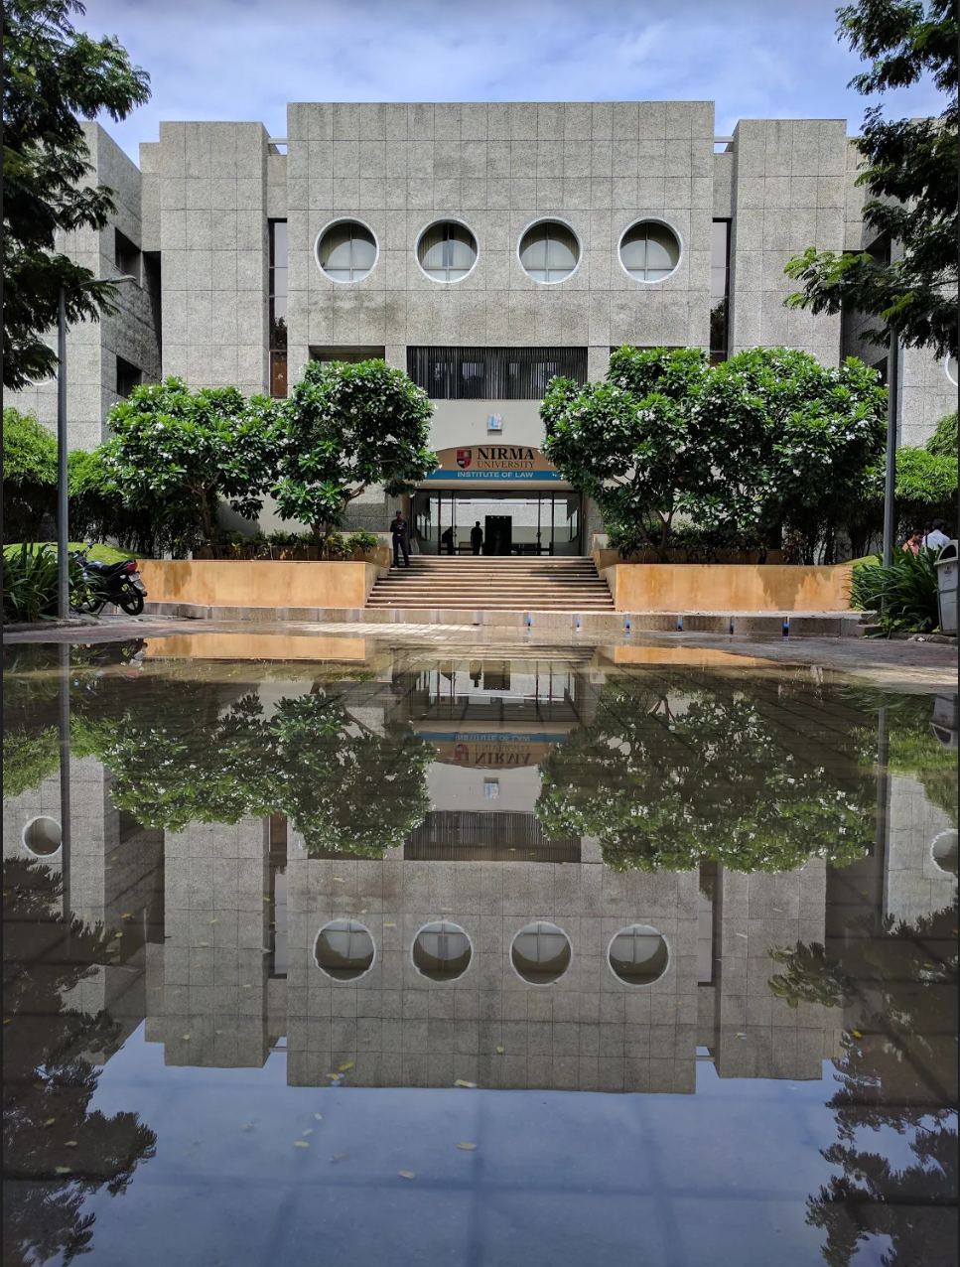

-: CORRESPONDING ADDRESS:-

Institute of Law, Nirma University
Sarkhej Gandhinagar Highway, Ahmedabad
Gujarat : 382481
Conference Email: rgajeconference@nirmauni.ac.in
Website: www.ilnuconference.org/rgaje

The Regional Conclave on The Future of Justice Education in South Asia has been made possible through the generous support of Nirma University and a grant of USD 500 from the Regional Committee of the Global Alliance for Justice Education (GAJE)

